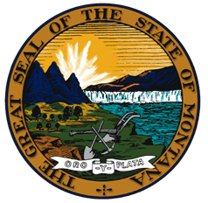

Montana Voting System Certification Event
Montana Secretary of State Linda McCulloch
Elections and Government Services • soselections@mt.gov • www.sos.mt.gov

NOTICE:

Pursuant to Montana Code Annotated and Administrative Rule, Elections Systems and Software (ES&S) applied for a certification upgrade from Unity 3.4.0.0 to Unity 3.4.1.0.

Unity 3.4.1.0 is federally certified and includes updates to two tabulation machines currently being used in Montana Counties, the DS200 and the DS850. It also includes firmware updates on the Election Reporting Manager (ERM), and Hardware Programming Manager.

On June 16th at the State Capitol beginning at 9:00 AM, staff from the Secretary of State’s office will be marking test ballots to be used in the certification event. The certification event will take place June 17th at the State Capitol, Room 303 in Helena, MT beginning at 9:00 AM. The test ballot marking and certification event are open to the public.

The ES&S application can be found here.

More information on Montana’s requirements can be found in Montana Code Annotated Title 13 Chapter 17 and Administrative Rules of Montana 44.3.17.
If you have any questions about the certification event, please contact soselections@mt.gov.

