

**INSTRUCTIONS FOR VOTING AN ABSENTEE BALLOT**

**Read carefully and follow all directions –**

**Vote only one party ballot**

**Ballots must be received by election office by 8 p.m. on June 5, 2018**

***Failure to follow directions may invalidate part or all of your ballot***

1. **VOTE YOUR BALLOT**

* Completely fill in the oval for each race using only black or blue ink pen.
* Vote in all columns and both sides of ballot(s) as applicable. *Skipping a race will not invalidate your ballot.*
* **Do not** make an X, √, or another mark.
* **Do not** cross out, erase, or use correction fluid.
* **Do not** make any identifying marks on your ballot.
* **Do not** mark more choices than allowed for each race (overvote) as that will cause that race only to not be counted.

**SAMPLE OVERVOTED RACE**

**For United States Representative**

**(Vote for One)**

John Doe

Void Overvote

Thomas Jefferson

Jane Q Public

* To write in a candidate’s name, completely fill in the oval to the left of the line provided and print the name in the blank space.

**SAMPLE WRITE-IN VOTE**

**For United States Representative**

**(Vote for One)**

John Doe

* If you make a mistake or spoil your ballot, request a replacement ballot from the election office.

1. **PREPARE BALLOT FOR SUBMITTAL**

* Place VOTED ballot in the SECRECY ENVELOPE and seal the envelope (if multiple sheets, return all sheets of the ballot).
* Place UNVOTED ballot in unvoted ballot envelope and seal the envelope.
* **SIGN YOUR signature** on the voter affirmation on the back of the Signature Envelope. Failure to sign may invalidate your ballot.
* If the signature on the affirmation does not match the signature on file, the ballot may be rejected.
* Place the Secrecy Envelope containing your voted ballot, and the unvoted ballot envelope into the Signature Envelope and seal the envelope.



1. **RETURN BALLOT**

* Mail your ballot: USPS recommends that you mail

at least one week before the election; **or**

* Drop off ballot at election office:

________________________COUNTY ELECTION OFFICE

Address____________________________________________

City/Zip____________________________________________

* **Ballots must be received at the election office by 8 p.m. on Election Day, June 5, 2018.** *(Note: a postmark cannot be accepted so if you mail your ballot make sure there is enough time for it to reach the election office.)*

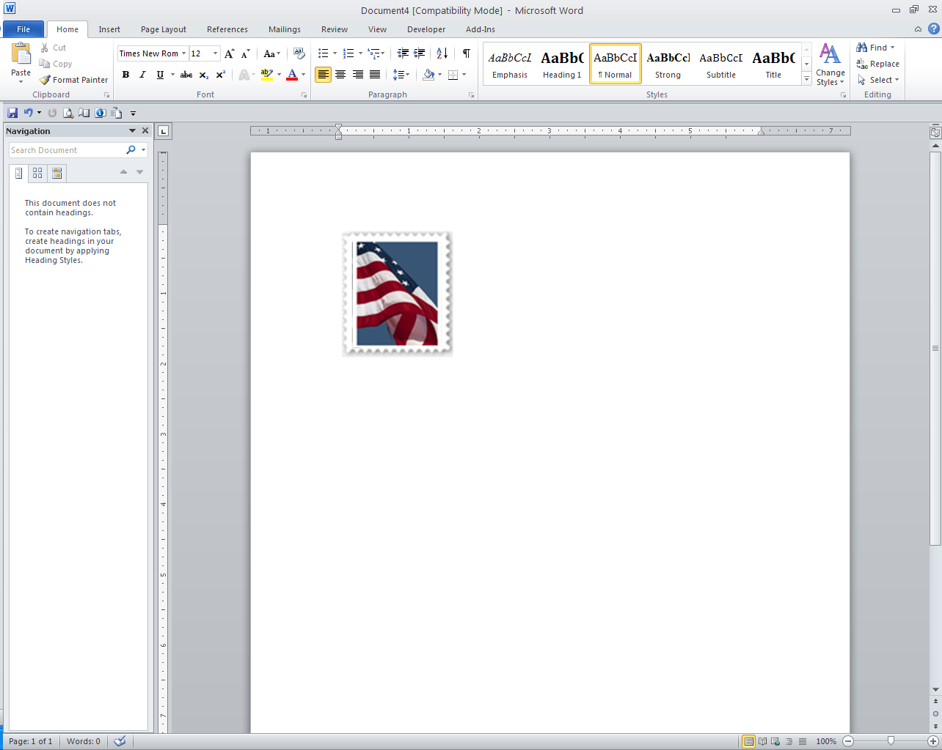

* *DO NOT FORGET POSTAGE IF MAILING:*

*_____ cents postage required*

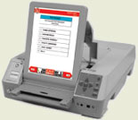**ASSISTANCE FOR VOTERS WITH DISABILITIES**

There are options for voters with disabilities including equipment for individuals with visual and mobility impairments. Contact your county election office for information about all options.

 **TRACK YOUR BALLOT**

You can confirm the status of your absentee ballot for any Federal Election and review the Voter Information Pamphlet (if applicable) on “My Voter Page” found at [sosmt.gov/Elections](http://www.sosmt.gov/Elections).

** MILITARY/OVERSEAS VOTERS**

If you are an active-duty absent military

voter or overseas citizen, registration

and voting activities can be done

electronically. See [sosmt.gov/Elections](http://www.sosmt.gov/Elections).

**IF YOU HAVE QUESTIONS CONTACT THE ELECTION OFFICE AT:**

__________________________ County Election Office



Phone: 406-____________________________

Fax: 406-____________________________

Email: ________________________________

*Updated October 26, 2017*