ARM REPLACEMENT PAGE
REQUIREMENTS AND TIPS
MARCH 2018

Administrative Rules Services
Office of the Secretary of State
(406) 444-9000
www.mtrules.org
ARM REPLACEMENT PAGE
REQUIREMENTS AND TIPS
MARCH 2018

Table of Contents

Page

General Reminders 2

What You Must Submit 3

Basic Formatting 4

Make These Your Default Settings 5

When Converting Fonts and Margins, Change This on All Pages 13

Table of Contents Pages 14

Cross Reference Table Pages 14

Rule Pages 15

History Notes 16

What You Can and Can't Do Without Going
Through the Register 17

Checklist: Before Submitting RPs 18
General Reminders

ARM staff does not compare your RPs with the Register notices or with existing pages, so make sure you have proofed all changes before submitting, and that the pages are accurate and print-ready.

Don't retype rules! Errors are always introduced when rules are retyped. If the rule is 1997 or later and you don't have it electronically, contact ARM Services. If your last possible option is retyping it, proof out loud with two people. If your other last possible option is taking it off the web, you will need to reformat the rule from the online version so that it matches the hard copy:

  - From the web site, highlight rule text and copy onto an RP template page.

  - Highlight text, then go to the tool bar and select Format, then Styles and Formatting, then Clear Formatting.

  - Change all the font to 12 point Arial, left justified.

  - Remove the hyperlink in the rule number (right click on link and select Remove Hyperlink). Replace the underline on the rule number and the catchphrase.

  - Move (1) and at least one word up to same line as catchphrase if there is room.

  - Reset tabs and reinsert indents to .5".

  - Check that there are two spaces after the rule number and all earmarks.

  - Move history note up to follow last section. To reformat the history note:

  - Remove hyperlinks.
  - Underline the IMP and the action types, NEW, AMD, TRANS, REP.
  - Delete the space between the action type and the comma.
  - Add parentheses around the history note.

There are "templates" in your RP subfolder in your agency's share folder (where you submit notices and RPs). They will help you see where to place tabs and how to properly and consistently format your 2018 replacement pages. If you are unable to access the share drive, contact ARM staff for replacement page templates.

General Reminders, continued

Print out all your pages for a final review before you submit them. Just looking at the hard copy will reveal easily fixed errors (for example, footings in the middle of the page instead of at the bottom, or fully justified rules instead of left justified).

Naming your files: ARM Bureau prefers that you submit your pages as individual files; however, you may submit consecutive pages in a single file. Don't add periods or spaces to the file name.

  - If you are submitting nonconsecutive pages, save each page as an individual file. Name your files using only the page number and "rp" indicator, e.g., 44-1089rp.docx for individual page 44-1089.

  - For consecutive pages, name the file only with the beginning and ending page numbers and "rp" indicator, e.g., 44-1089 - 1096rp.docx for all consecutive pages 44-1089 through 44-1096.

What You Must Submit

If you amended a rule, adopted a new rule, transferred a rule, or repealed a rule, submit just the changed pages for that rule.

If the rule is in a subchapter that has not yet been converted to Arial, submit the entire subchapter (not the entire chapter).

Once a subchapter has been converted to Arial, you can go back to submitting just the changed pages.

If a chapter's table of contents has not yet been converted to Arial, submit the entire chapter's table of contents if it has a change (for example, added a new rule, changed a catchphrase, or added (REPEALED) or (TRANSFERRED) after the catchphrase).

If you added a new chapter, changed a chapter name, or changed the beginning page number of a chapter, make the changes on the main chapter table of contents (at the very beginning of your title) and submit it, too.

Basic Formatting

Top and bottom margins: .5" Left margin: 1.5" Right margin: .75"

Font: Arial 12

Justification: left

All pages must be submitted electronically in Word, including organizational charts. All text must fit within the specified margins.

Heading typed on line 1 (.5"); footing typed at 10.2" (do not enter headers and footers as in the Register).

Even if only the formatting changed on a page, the page date must be changed to reflect the current quarter. Every submitted page will say 3/31/18 at the bottom, in that format.

Odd-numbered pages are right-hand pages. Even-numbered pages are left-hand pages. You cannot reserve (NEXT PAGE IS) to an even-numbered page.

Two spaces (not tabs) between the rule number and catchphrase, between the catchphrase and (1), and after all earmarks.

Make These Your Default Settings
For Word 2007, click on the Office Button

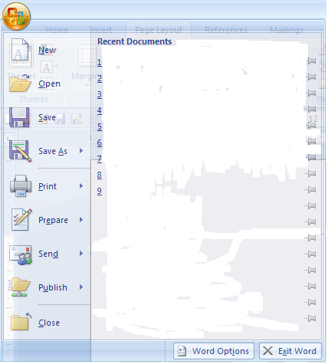

Then on Word Options.

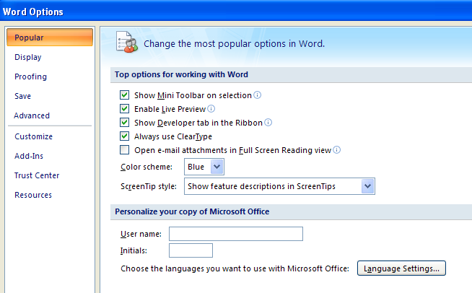

Then on Display.

Show all formatting marks.

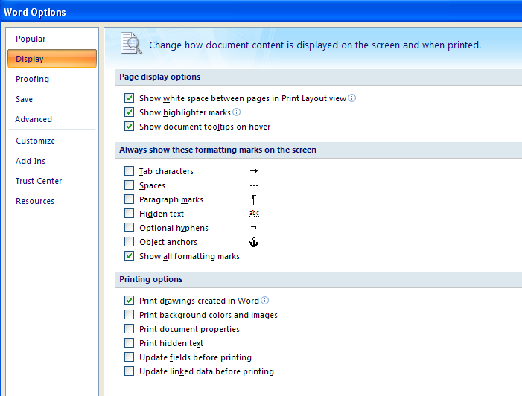

Then on Advanced to get Text Boundaries.

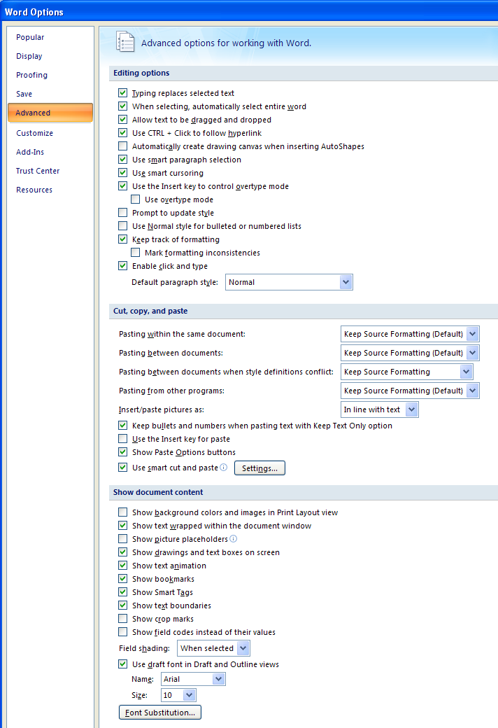

For Spelling and Grammar and AutoCorrect Options, click on Proofing.

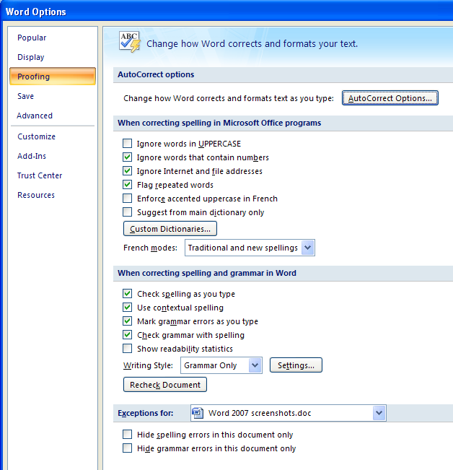

AutoFormat As You Type

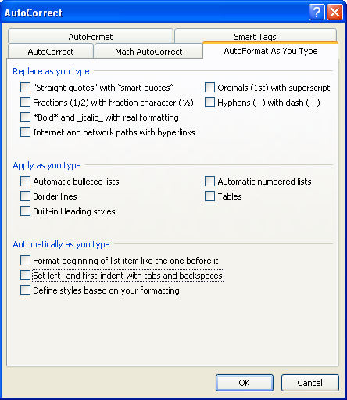
AutoFormat

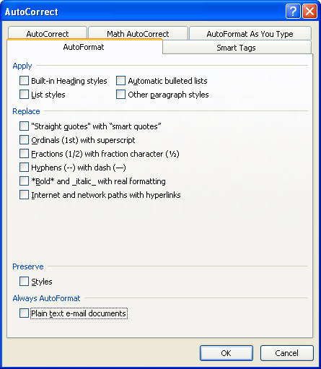
AutoCorrect

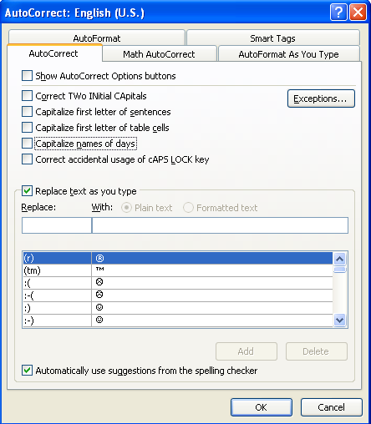

When Converting the Font and Margins, Change This on All Pages

Change capitalization when needed to comply with the Gregg Reference Manual (325 and 326 especially applicable). For example, uppercase any occurrences of "Department of ..." if it is the whole department name.

On table of contents pages and in rule text, remove hyphens in "subchapter."

For all reserved rules, use this format for ARM consistency:
Rules 44.2.103 through 44.2.106 reserved
(use entire rule number, lowercase "reserved," no period).

Change internal references if the rule has been transferred from a disbanded title (e.g., all Title 11, 16, 26, or 46 rules).

Update addresses, phone numbers, and web sites.

Remove any hard returns from the ends of lines which do not end a (sub)section.

Remove any hyphens in nonhyphenated words that are hyphenated at line ends. Keep the word whole, and let the text wrap itself.

In the History Notes, remove "Sec." and "and," and add commas before and after "MCA" if they are missing.

In the body of a repealed or transferred rule, the catchphrase must have (REPEALED) or (TRANSFERRED) between it and the history note (not IS HEREBY and not underlined).

Table of Contents (TOC) Pages

If the font and margins haven't been converted to Arial, submit entire chapter's table of contents if it has a change (for example, a new rule, a changed catchphrase, or if you need to update or add the (REPEALED) or (TRANSFERRED) after the catchphrase).

Remove hyphens in "subchapter."

"Subchapter ## reserved" lines are centered.

"Rule ##.##.### reserved" lines are aligned with the catchphrases.

For all reserved rules, use this format for ARM consistency (use entire rule number, lowercase "reserved," no period):
Rules 44.2.103 through 44.2.106 reserved

If a rule was repealed or transferred, add (REPEALED) or (TRANSFERRED) after the catchphrase. Remove any "IS HEREBY" text.

Look at the rules you didn't submit to see if (REPEALED) or (TRANSFERRED) needs to be added to the table of contents.

If you added a new chapter, changed the chapter name, or changed the beginning page number of a chapter, make the changes to the main chapter table of contents (at the very beginning of your title) and submit it, too.

Cross Reference Table (CRT) Pages

If there was a new rule, or the AUTH or IMP in a rule had an MCA added or removed, add or remove citations in the cross reference table and submit those pages. If more than one person from your agency submits notices, only one of you should prepare and submit the CRT for the entire agency.

Set the ARM column at a left tab 4.1". Select leader dot tabs.

Align the rule numbers with the ARM column header: left tab 4.1".
Rule Pages

Try to keep the entire rule on one page, if there is still at least 1" of space above the footer.

Do not split rules in midsection or sentence when continuing the rule on another page.

Try to keep subsections with the section.

Shift text so that more than half the page is full, but leave at least 1" of space between text and the footer on each page, to allow for future rule growth.

When rules shift to a different page, double-check and change the header rule number accordingly.

Reserve pages for future growth and to accommodate reserved rules, reserved subchapters, and reserved chapters.

The "NEXT PAGE IS" notation must be to an odd-numbered page, and is only used when the next page is not consecutive.

On right-hand (odd-numbered) pages, the header rule number is on the right and is the last rule on the page, and the header is the chapter name. On left-hand (even-numbered) pages, the header rule number is on the left and is the first full rule on the page, and the header is the department name.

Renumber pages to eliminate decimal point page numbers and to leave more room for reserved rules and subchapters. You can change the page numbers on "chapter reserved" pages to allow for renumbering of the next chapter's pages.

Even if only the formatting changed on a page, the page date must be changed to reflect the current quarter. Every page you submit must be dated 3/31/18 at the bottom.

In the body of a repealed or transferred rule, the catchphrase must have (REPEALED) or (TRANSFERRED) between it and the history note (not IS HEREBY and not underlined).

Do not use section or page breaks. Remove any existing section or page breaks.

Remove any hard returns from the ends of lines which do not end a section or a subsection. Let the text wrap itself to the next line.

Rule Pages, continued

Do not hyphenate nonhyphenated words at line ends. Keep the word whole and let the text wrap to the next line.

In the History Notes, remove "Sec." and "and," and add commas before and after "MCA" if they are missing.

Center all "Subchapter ## reserved" lines.

Tab to .5" for all "Rule ##.##.### reserved" lines.

For all reserved rules, use this format for ARM consistency:
Rules 44.2.103 through 44.2.106 reserved
(Use entire rule number, lowercase "reserved," no period).

If an unconverted "chapter reserved" page is adjacent to a submitted subchapter, also convert and submit the "chapter reserved" page.

History Notes

Update the history note for each rule changed in the Register. The updated history note includes the action type (underlined AMD, NEW, REP, TRANS, or AMD & TRANS), the year of the change (2018 MAR), the first page number of the adoption notice (p.), and the effective date. For example: ; AMD, 2018 MAR p. 90, Eff. 1/13/18.)

The effective date ("Eff.") is the day after publication (unless a later date is specified in the adoption notice) as follows:

Eff. 1/13/18 if your adoption notice was published in 2018 MAR Issue No. 1
Eff. 1/27/18 if your adoption notice was published in 2018 MAR Issue No. 2
Eff. 2/10/18 if your adoption notice was published in 2018 MAR Issue No. 3
Eff. 2/24/18 if your adoption notice was published in 2018 MAR Issue No. 4
Eff. 3/17/18 if your adoption notice was published in 2018 MAR Issue No. 5
Eff. 3/31/18 if your adoption notice was published in 2018 MAR Issue No. 6

If a corrected notice was done, change only the page number - the effective date remains the same as the day after publication of the adoption notice. The page number changes to the first page of the corrected notice.

Remove "Sec." and "and" from all history notes, even if the rule didn't change this quarter.

MCA citations should be in numerical order, and a comma should precede each "MCA."
What You Can and Can't Do Without Going Through the Register

NO Change: anything that could possibly change the meaning of the rule

YES Update: your organizational rule and chart

YES Correct: spelling errors if they do not change the meaning of the rule (e.g., "eror" to "error") or if the error is a typo that appeared correctly in the proposal and/or adoption notice but was incorrect on the replacement page
NO Correct: spelling errors if the meaning of the rule is changed (e.g., "not" to "now");
other errors

YES Change: addresses and add P.O. Box numbers;
phone numbers - use this format: (406) 444-9000;
web addresses;
department, division, bureau, and board names

YES Add: comma before MCA in rule text and history note
NO Add: comma (or other punctuation) anywhere else in your rules

YES Add: (1) to unearmarked single-paragraph rules (only in very old rules)
NO Change: other earmarking on rules

NO Delete: specific earmarked section references in text and/or history notes, e.g., 37-6-107(2) to 37-6-107, MCA

YES Change: numbers to words and vice versa using this rule: Spell out one through ten; use numbers for 11 and greater (per Gregg) (see Gregg 402 for exceptions to spelling out numbers)

YES Change: References such as "eleven (11)" to "11" and "two (2)" to "two"

YES Delete: the words "section" and "subsection" from the text of your rules (e.g., "...referenced in section (5)." to "...referenced in (5).")

Reminder: The online version at mtrules.org only updates rules that had actions (adopt, amend, repeal, or transfer) in the current quarter. If you make any of the above changes to the print copy of a rule that had no actions this quarter, please let ARM staff know so we will be able to update the online version to match the print version.
Before Submitting RPs

1) As you prepare your replacement pages:
Accept any "track changes" features which were in the proposal or adoption notices, then turn off the track changes feature. ARM Services cannot accept RPs with track changes in the document.
Copy and paste from the proposal notice, adoption notice, and any corrected notices. The correct version of the files to work from will have "-arm" in the file name.
Confirm the RP file you're working from is the updated and correct version of the page by comparing it to the hard copy in the green binders.
If you do not have an electronic version of the RP, contact ARM Services. Do not retype the page, and do not copy it from a web page.
Use two people to proof your finished page, and proof from the proposal notice, adoption notice, and original RP.
If the rule's AUTH or IMP citations changed, add or remove citations in the Cross Reference Table.
If the rule's catchphrase changed, change it in the chapter table of contents.
Name the file with the page number and an "rp" to properly identify the content of the file. For example, 44-5rp.doc to show the file is page 44-5, or 44-5 - 8rp.doc to show the file contains pages 44-5 through 44-8.

2) Print out all the pages you are submitting.
Is the page left justified?
Is the header on line 1 and the footer at 10.2"?
Are rule numbers and sections/subsections indented to .5"?
Do right-hand pages have odd page numbers and vice versa?
Is the entire page in Arial 12?
Do headers on right-hand pages have the chapter name and last rule number on the page?
Do headers on left-hand pages have the first rule number on the page and the department name?
Is the quarter date in the footer the last day of the quarter you're submitting for, and formatted correctly? (e.g., 3/31/18)
Did you leave at least an inch of empty space between the text and the footer at the bottom of the page to allow for future expansion?
Does the page break at a logical place? In other words, does it break at the end of a section/subsection, and not in the middle of a section or sentence?

3) Double-check the content.
In the consecutive pages you are submitting, are rule numbers sequential? If rules are reserved, are they accounted for in the rule pages and the chapter table of contents?
Are reserved subchapters and chapters accounted for in the rule pages and the chapter table of contents?
Check the sections/subsections (earmarks). Are they all there and sequential?
Has all interlined text been removed? Has underlining from new text been removed?
If a rule refers internally to other rules, are those rule numbers still valid?
Do the history notes have the correct information in the correct format?
AMD, 2018 MAR p. 90, Eff. 1/13/18 means the rule was adopted in the 2018 Montana Administrative Register; the notice of adoption began on page 90 (use the page number of the adoption notice, not the proposal notice); and the rule change was effective on 1/13/18, which is the day after the adoption notice was published.

